Spring Data JPA

- 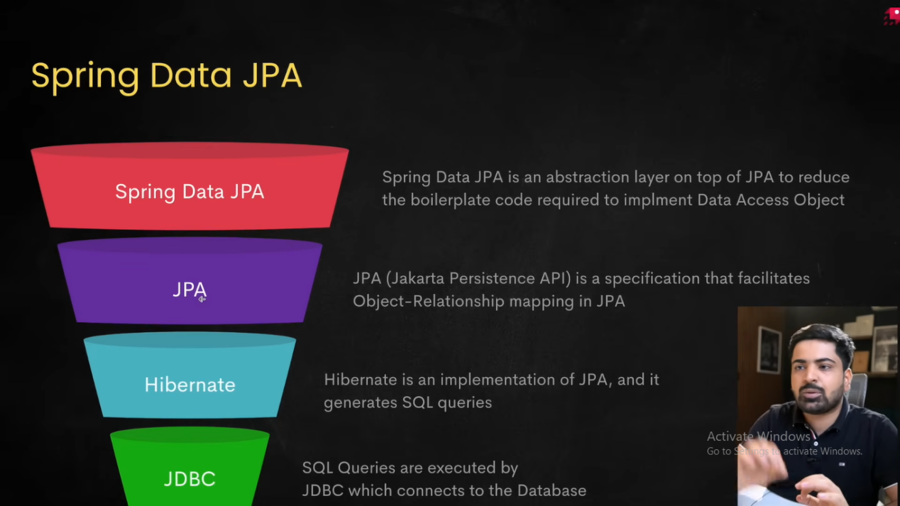

- @Target(ElementType.METHOD)
@Retention(RetentionPolicy.RUNTIME)
@Documented
public @interface MyAnnotation { // we are making our own annotation
}
@Target - Specifies where an annotation can be used. ElementType.TYPE is used on Class, Enum, Interface. FIELD is used on variables, METHOD is used on methods.
All is also possible.
@Target({
ElementType.TYPE,
ElementType.METHOD,
ElementType.FIELD
})

@Retention - Decides how long the annotation should be retained.
SOURCE - Annotation disappears after compilation, not present in .class file.
CLASS - Default policy.
RUNTIME - Annotation remains available even after the JVM loads the class.
@Repository, @Service, @Controller all use RUNTIME.

@Documented - Controls whether the annotation appears in the generated Java documentation (javadoc).

** There is a difference between class and interfaces. Class can extend only one class but interfaces can extend multiple interfaces.
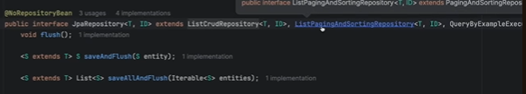

Ques. If JpaRepository is continuosly extending other interfaces then how do we get value when we write repository.findAll()?
Ans. There is one concrete class implementing JpaRepository called SimpleJpaRepository. It has an entityManager object which helps it implement every method we use for querying, namely, findById(), findAll(), etc.

- EntityManager
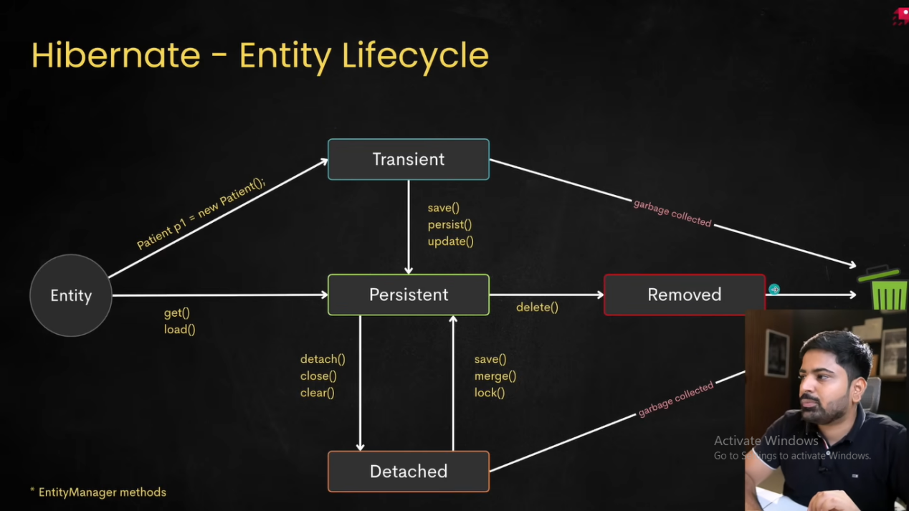
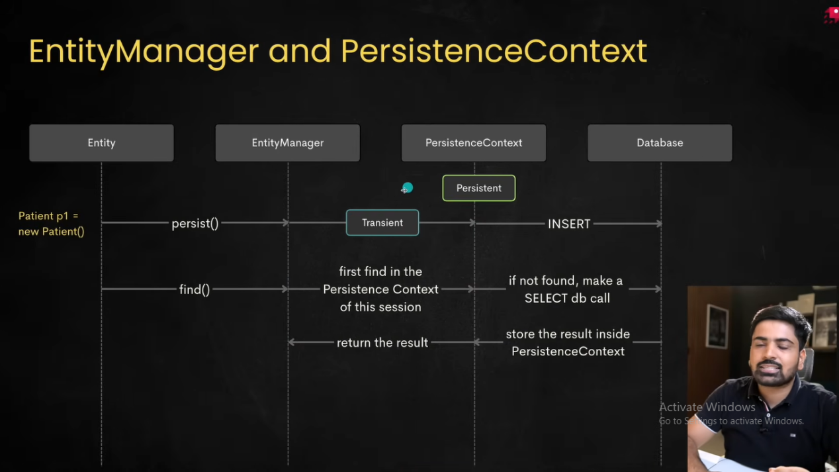

@PersistenceContext - Acts like a first layer cache. Transient state hasn’t committed yet to the DB. If save(), persist() method is called, then it gets saved to persistent layer.

- @Table - used to execute some hibernate operations from the code itself. Like changing the table name, adding unique constratints, add indexes etc.
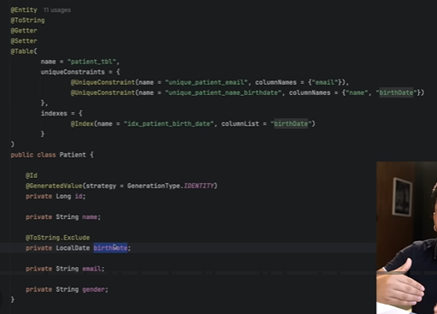

@Column - To customize column name, add unique constratints, length (size), precison (decimal digits) etc.
@Column(unique = true, nullable = false, updatable = false) etc etc.

@CreationTimeStamp
private LocalDateTime createdAt;

@Enumerated(EnumType.STRING)
private BloodGroupType bloodGroup;
By default, enum stores ordinal values ( 1,2,3…) which is good for prod env.

Entity class we use camel casing which automatically converts to snake casing in the DB. Ex: bloodGroup --> blood_group

If no custom @ToString is inlcuded with the entity/DTO class then printing the object returns className@HashCodeValue. We can also exclude using @ToString.exclude.

- Data Seeding (initial data) - data.sql file under resources folder having insert query. Classpath means files under resources folder. createdAt column will be [null] when we use data seeding to insert data into the table. When client inserts data, then it works as expected.

- Query methods: Visit spring data jpa query method page of spring doc.
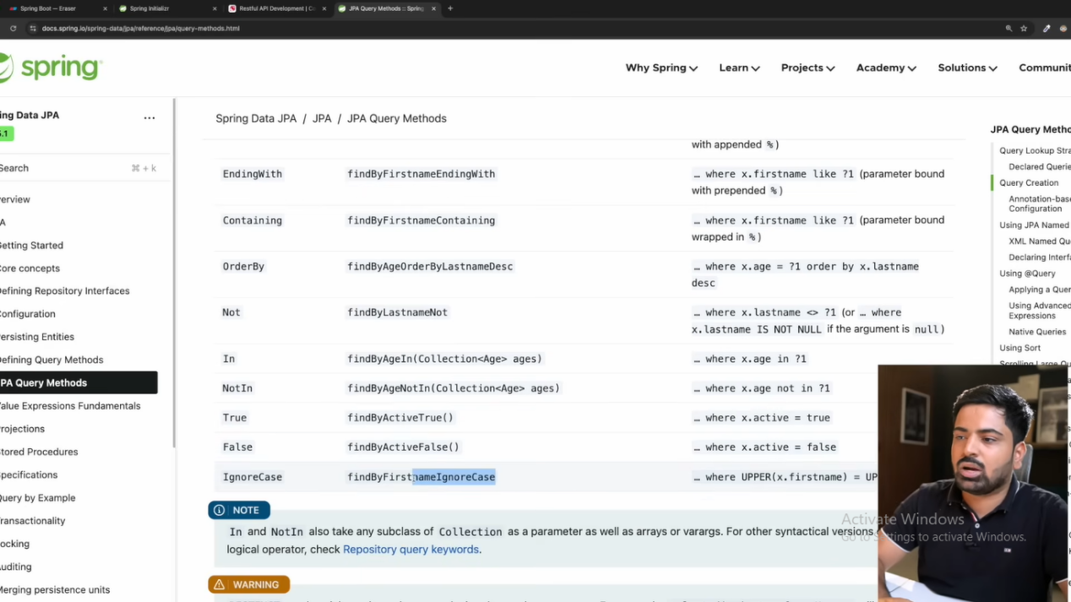

- JPQL
@Param
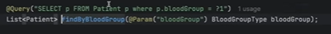

Constructor expressions:
@Query("""
SELECT new com.demo.dto.EmployeeDTO(
e.name,
e.salary)
FROM Employee e
""")
List<EmployeeDTO> getEmployeeDTO();

Named Parameter:
@Query("""
SELECT e
FROM Employee e
WHERE e.department=:dept
""")
List<Employee> getEmployees(String dept);
Or
List<Employee> getEmployees(
@Param("dept") String department);

Positional parameter
@Query("""
SELECT e
FROM Employee e
WHERE e.department=?1
""")
List<Employee> getEmployees(String department);

Multiple conditions
@Query("""
SELECT e
FROM Employee e
WHERE e.department=:dept
AND e.salary>:salary
""")
List<Employee> findEmployees(
String dept,
double salary);

Pagination

@Query("""
SELECT e
FROM Employee e
""")
Page<Employee> findEmployees(Pageable pageable);
Page<Employee> page =
repository.findEmployees(
PageRequest.of(0,10));

Native query

@Query( value = “select * from employee” , nativeQuery = true)
List<Employee> findAllEmployees();

Update query
@Transactional
@Modifying
@Query(“update employee e set e.name = :name where e.id = :id”)
int updateNameWithId(@Param(“name”) String name, @Param(“id”) Long id);
@Modifying tells JPA to register this action as a transaction since it is modifying values.

- Projections
@Query(“select new com.example.BloodGrpCountDto(p.bloodGroup, Count(p))
From patient p group by p.bloodGroup”)
List<BloodGrpCountDto> countEachBloodGroupType();

- Pagination

@Query(“select p from patient p”)
Page<Patient> findAllPatients (Pageable pageable)

Page<Patient> patientList = patientRepository.findAllPatients(PageRequest.of(0,2,Sort.by(“name”));
PageRequest.of(<PageNumber>, <PageSize>, Sort.by(“name”)

For(Patient patient : patientList){
System.out.println(patient);
}

- Association
A. @OneToOne
Patient and Insurance has one-to-one mapping. Every patient can have one insurance. Patient class will have one attribute named insurance. One extra column will get added to the patient table with the name stated in @JoinColumn.
@OneToOne
@JoinColumn(name = “patient_insurance_id”) //to customize column name in the patient table
private Insurance insurance; // foreign key

Similarly, Insurance class will have patient attribute.
@OneToOne(mappedBy = “insurance”) //inverse side
private Patient patient;

Relationship | Owner Side
OneToMany / ManyToOne | @ManyToOne side (the side with the foreign key)
OneToOne | Side with @JoinColumn (any of the two tables)
ManyToMany | Side with @JoinTable (any of the two tables)
A useful rule is:
- @JoinColumn or @JoinTable → Owner side
- mappedBy → Inverse side
** First decide which class is the owner. For @OneToOne and @ManyToMany, it can be any class. Use @JoinColumn and @JoinTable respectively, while the inverse class will have “mappedBy”. For @ManyToOne (inverse class will be @OneToMany), the owner will be the class with @ManyToOne annotation (+@JoinColumn), while the inverse class will have @OneToMany(mappedBy=”….”).
** Owner table will have inverse table info but not vice-versa. Patient table will have insurance_id column as a foreign key but insurance table will not have any information about the patient.
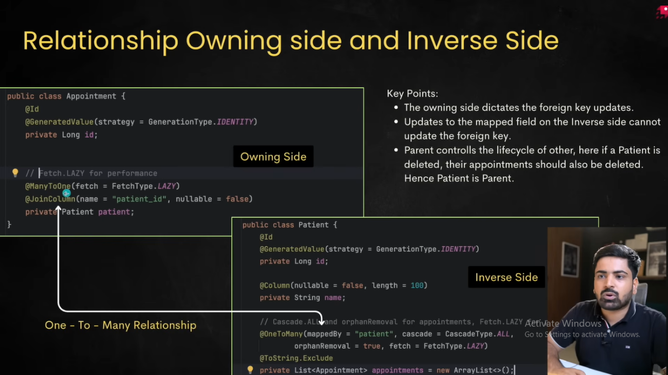
b. @ManyToMany
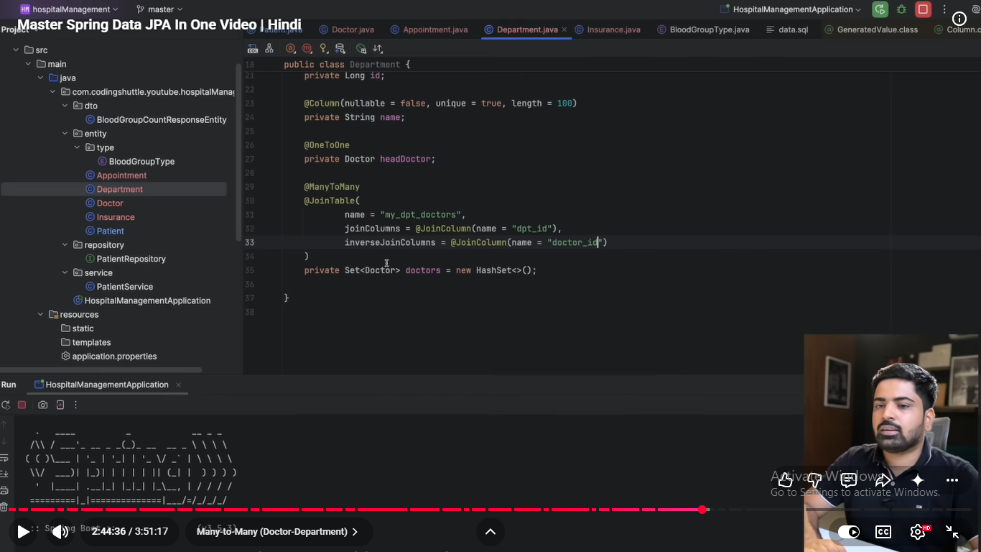
Private Set<Doctor> doctors = new HashSet<>();
We need to instantiate it so that Hibernate doesn’t get null.
To make it bidirectional, use mappedBy in Doctor class.
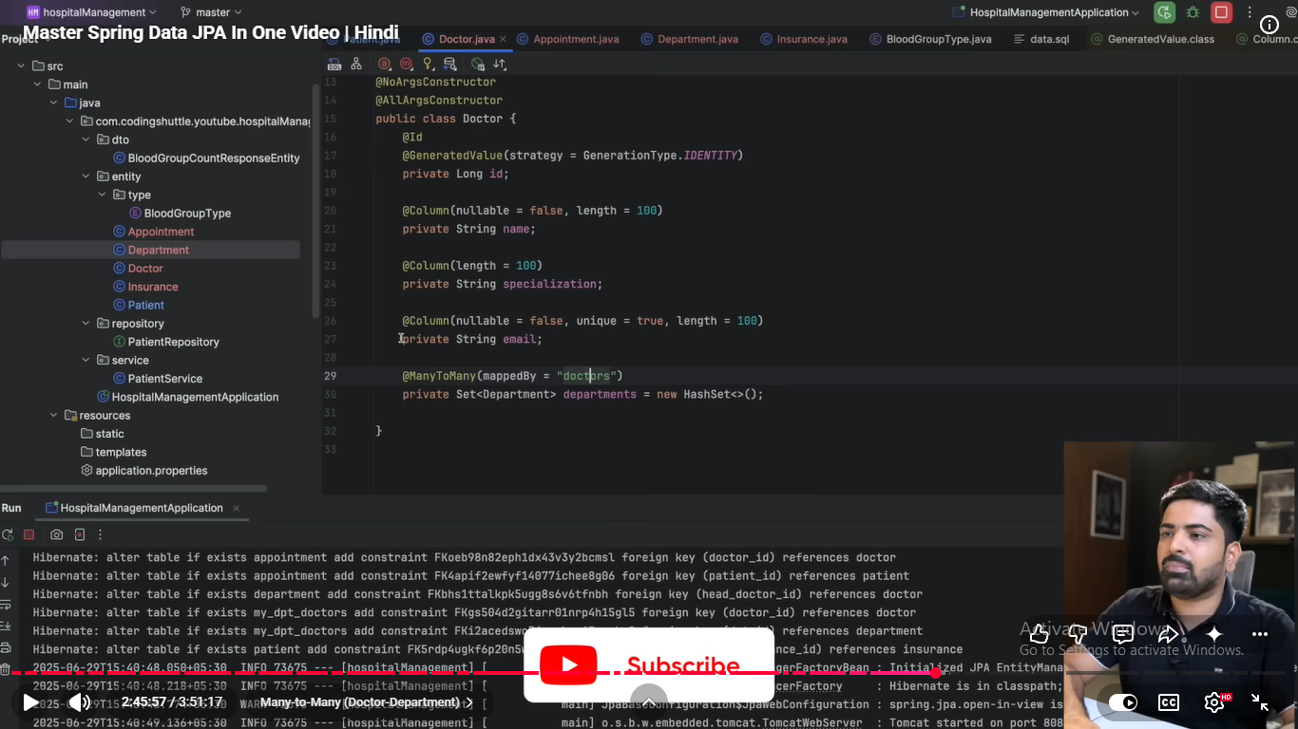

Entiry-Relationship Diagram (ER diagram)
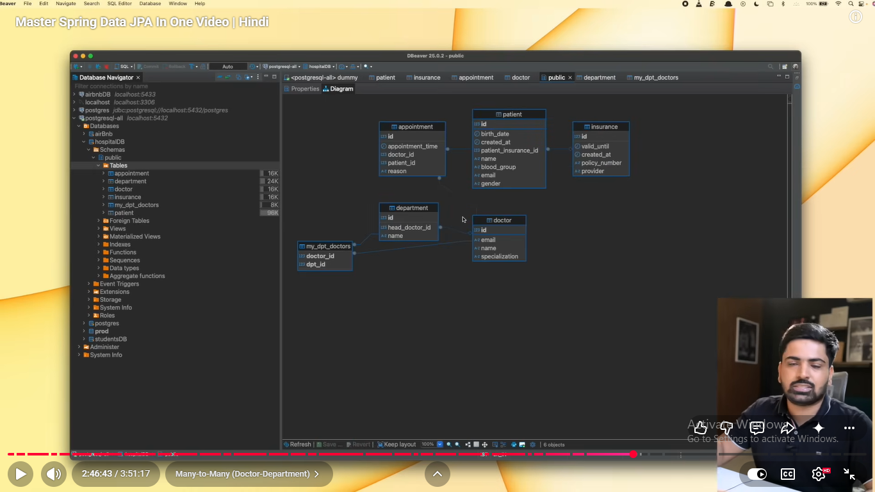

- Cascading in JPA
Ans. An operation performed on a parent entity is automatically propagated to its related child entities.
Save Parent
↓
Child is automatically saved
Cascade Type | Effect
PERSIST | Saves child when parent is saved
MERGE | Updates child when parent is merged
REMOVE | Deletes child when parent is deleted
REFRESH | Reloads child from the database when parent is refreshed
DETACH | Detaches child when parent is detached
ALL | Applies all of the above
Ques. What is the difference between CascadeType.REMOVE and orphanRemoval=true?
Ans.
- CascadeType.REMOVE deletes child entities when the parent is deleted.
- orphanRemoval=true deletes a child entity when it is removed from the parent's collection, even if the parent itself is not deleted.
Roles are reversed here. Acc to JPA, Appointment is the owner side, Patient is the inverse side. But from data side, Patient is the Parent and appointment is the child. Cascading is done in the parent.
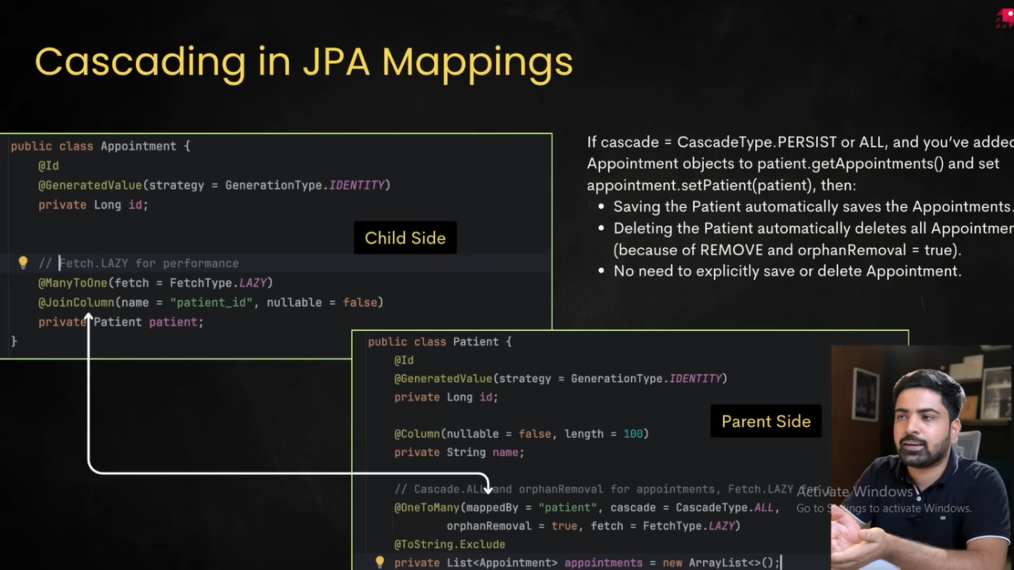

Cascade is not determined by the owner or inverse side. It is placed on the side from which I want persistence operations to propagate. In practice, I usually put it on the parent entity, because the parent owns the lifecycle of its children.
- FetchType
FetchType determines when Hibernate loads an associated entity from the database.
FetchType.LAZY - With LAZY, Hibernate loads the associated entity only when it is first accessed.
FetchType.EAGER - With EAGER, Hibernate loads the associated entity immediately.
Relationship | Default Fetch Type

@ManyToOne | EAGER

@OneToOne | EAGER

@OneToMany | LAZY

@ManyToMany | LAZY
- Difference between
JPA | Hibernate | Spring Data JPA
Specification | Implementation | Framework
Defines APIs | Implements APIs | Simplifies JPA usage
No implementation | ORM provider | Repository abstraction

What is Persistence Context?
Ans. Persistence Context is the first-level cache where Hibernate stores managed entities.
Database
↑
Persistence Context
↑
EntityManager
If entity already exists inside persistence context. No SQL executed.
employeeRepository.findById(1);
employeeRepository.findById(1);
No Sql hit for the second query as it is fetched from the persistence context.

What is Dirty Checking?
Ans. One of Hibernate's biggest features.
@Transactional
public void update(){
Employee e = repository.findById(1).get();
e.setSalary(70000);
}
No save() called.
Still
UPDATE Employee
SET salary=70000
Why?
Dirty checking.
Hibernate compares original snapshot with current object before transaction commit.
- Lazy loading
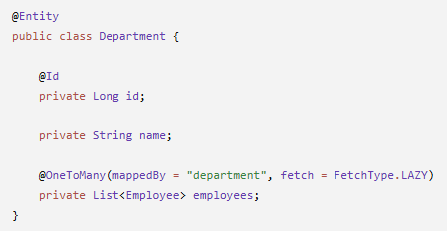
Department class is the parent here with employees as it child.
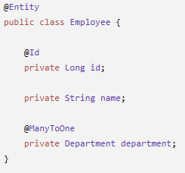
Lazy means Load the parent now. Load the child only when it is actually needed.
Department dept = departmentRepository.findById(1L).get();
System.out.println(dept.getName());
SQL queried: select * from department where id = 1;
Employee table is not queried.
When dept.getEmployees().size(); then select * from employee where department_id = 1;
SQL queried: select * from employee where department_id = 1L;
So the employee data is loaded only when they are accessed.
- Eager loading
Load everything immediately.
@OneToMany(fetch = FetchType.EAGER)
private List<Employee> employees;
Department dept = repository.findById(1L).get(); loads Deparment + Employee.
- What is N+1 query problem?
Ans.
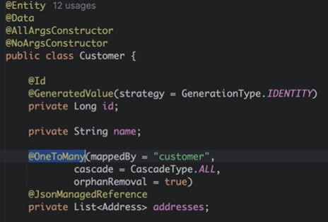
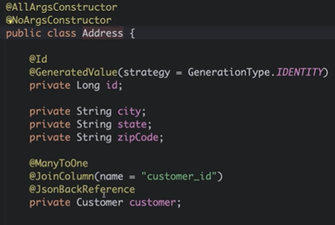
If we have to fetch all the customers with their addresses (findAll() method), we need to run N+1 (3+1) queries. 1 query to fetch all the customers, 3 queries to fetch addresses with their respective customerID.
Solution: Use @EntityGraph or FETCH JOIN
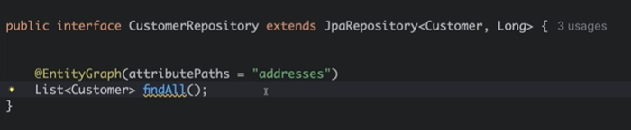
Here, “addresses” is the attribute name in the Customer class. Now when we hit findAll() method, it runs a single query which has LEFT JOIN already implemented. Total number of DB hit = 1.
Second option: use join fetch
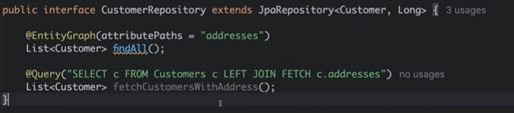
- Optimistic locking
Ans. Optimistic locking assumes: Conflicts are rare, so don't lock the data while reading. Instead, detect conflicts when updating.
Ex: E-commerce, Google Docs. Suppose two people edit the same document.Person A saves first.Person B tries to save later.Google says
"This document has changed. Refresh before saving."
No one blocked anyone. Conflict detected only during save.
That is Optimistic Locking.
User A --------Read(version=1)-----------Update Success(version=2)
User B --------Read(version=1)----------------Update Failed
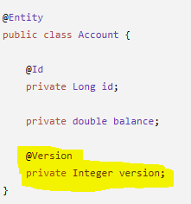 Enough to implement optimistic locking in the DB.
- Pessimistic locking
Ans. It assumes that conflicts are likely, so lock the data immediately. Once one user reads the row for update, no one else can modify it until the transaction ends. Like IRCTC booking, BMS booking, stock trading.
@Lock(LockModeType.PESSIMISTIC_WRITE)
@Query("select a from Account a where a.id=:id")
Account findByIdForUpdate(Long id);

